In your browser type---
http:localhost/EXTENSION
In the upper right corner you can find the Login button. Click it to login as user or admin.

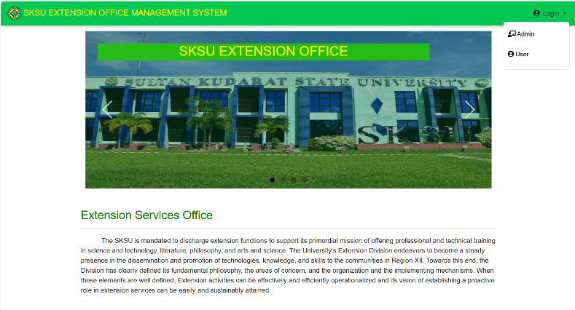

For signing as Admin just click the Admin button or just simply go to the link---
localhost/EXTENSION/Private_Dashboard/index.html
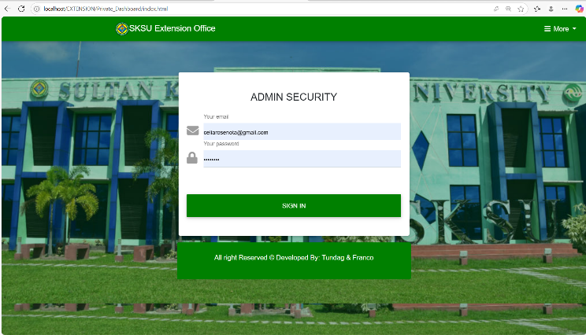

In the Admin login page the default email and password is:
Email - celiarosenota@gmail.com
Password – maamnota

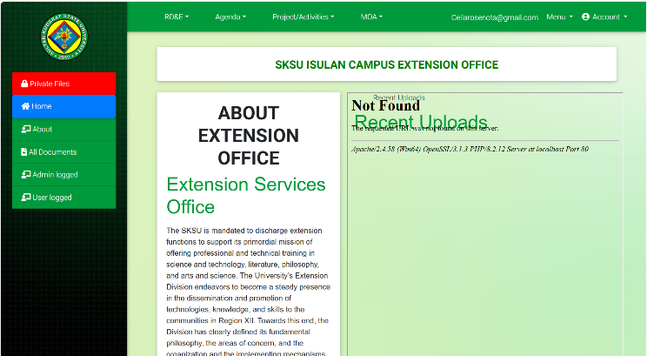

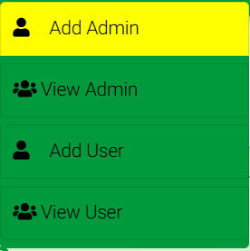
After logging-in, this is the dashboard or user interface of the admin.


The Menu button in the upper right part is for adding admin and user, and for viewing the admin and users.

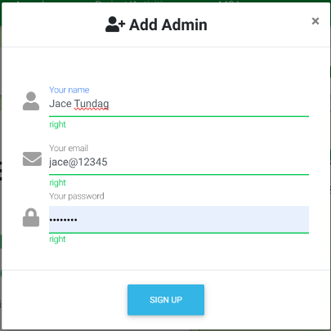
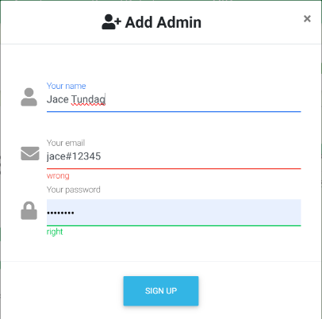
To successfully add an admin or user, make sure the email address contains the ‘@’ symbol. Without it, the system will not allow the account to be registered.

WRONG
RIGHT
For the dropdown that categorize the files breakdown:
NABA Agenda

RD&E
NEDA
Forms
RD&E manuals
Manual of operations
CCS Agenda

Engineering Agenda

Campus Agenda

NABA
CCS
Engineering
PPMP
Pool of Experts
Budgetary
Funded Projects
NABA
CCS
Engineering
Programs
Travel Order
MOA
MOA
Colleges Projects
Project/Activities
University Agenda

Agenda
Progress Report

Post Format

Proposal Format
Regional
To access all non-private files, simply click the 'All Documents' button on the left side.
After clicking the 'All Documents' button, all non-private documents can be viewed, downloaded, or deleted using the action icon on the left side of the table.
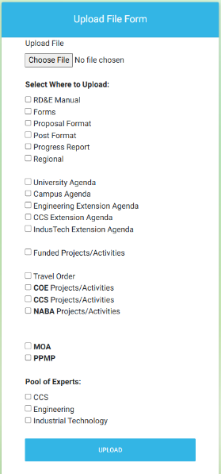
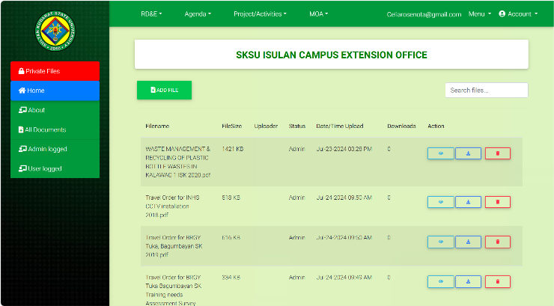
You can also add files by clicking the ‘ADD FILE’ button.
"After clicking the 'ADD FILE' button, click 'Choose File' and select the file you want to upload. Next, check the folder from the checklist where you want the file to be stored. If the file does not belong to any specific folder, simply click 'Upload'. Please note that only one file can be uploaded at a time, and it must be in .pdf, .docx, or .jpg format."

For the Users dashboard
localhost/EXTENSION/private_user/home.php
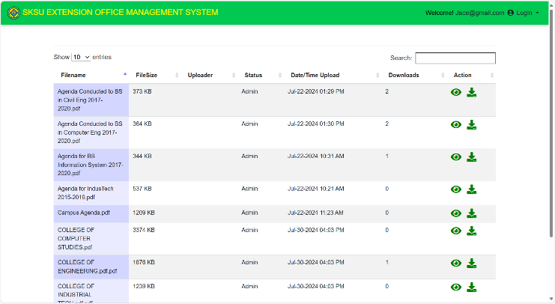
This interface allows users to view and download files only. It also features a search button to help locate files more efficiently.
Default Email and Password for user:
Email – jace@gmail.com
Pass – fordago

For Accessing the PRIVATE FILES
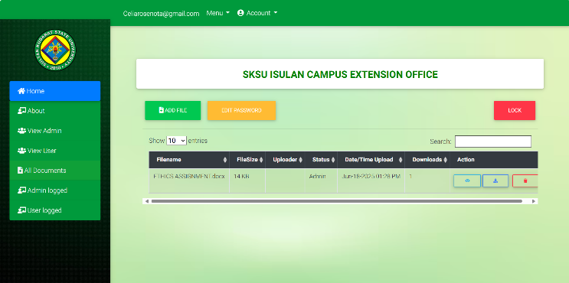

Accessing the private files requires a password for security purposes.
Default password : jace
You can add files here, edit the password, and lock the section to require a password upon future access. If you do not lock it, the private files will remain accessible without a password.

